**Software Project Design Plan**

Voice Controlled Drone

Aldwin Akbar Hermanudin

Rudy Nurhadi

Tomi

**Software Project Design Plan**

**for**

***Voice Controlled Drone***

***Aldwin Akbar, Rudy Nurhadi, Tomi***

***October 13rd 2015***

|  |  |  |  |
| --- | --- | --- | --- |
| **Version** | **Release Date** | **Responsible Party** | **Major Changes** |
| 0.1  0.2 | October 5th 2015  October 13rd 2015 | Team Leader  Team Leader | First Draft  Second Draft |
|  |  |  |  |
|  |  |  |  |
|  |  |  |  |
|  |  |  |  |
|  |  |  |  |

**DESIGN**

Designing is the process in which the team creates a specification of a software artifact, intended to accomplish goals, using a set of primitive components and regarding the constraints. Designing is the step of conceptualizing, planning, and understanding the foundation and process of the projects.

* **UML Diagram**

UML, which stands for Unified Modeling Language, is really important as the pre-process state. This object-oriented system of notation has been evolved from the works of Grady Booch, James Rumbaugh, Ivar Jacobson, and the Rational Software Corporation. These renowned computer scientists fused their respective technologies into a single, standardized model. Today, UML is accepted by the Object Management Group (OMG) as the standard for modeling object oriented programs. UML defines many kind types of diagrams: class (package), use case, sequence, activity, and deployment.

1. **Use Case Diagram**

This diagram shows the user and what “Voice Controlled Drone” system provides for them. In this case, the application lets users sent data from voice to command the drone. The android system in the diagram below provided several things a user can do with the apps. The apps android will give you the access to monitor drone status the command the user have given to the drone. The monitor status is called the feedback if the command is successful. There are several uses of the apps to control the drone. The apps let you easily command your drone to record video from you drone, capture picture from the drone, command your drone through voice recognition whereas the voice is translated into a string of data and sent to the drone via internet. To anticipate any unwanted incident we develop one more uses to control the drone. A manual override system is intended to control the drone manually with your phone if the drone failed to get command from the voice recognition application.

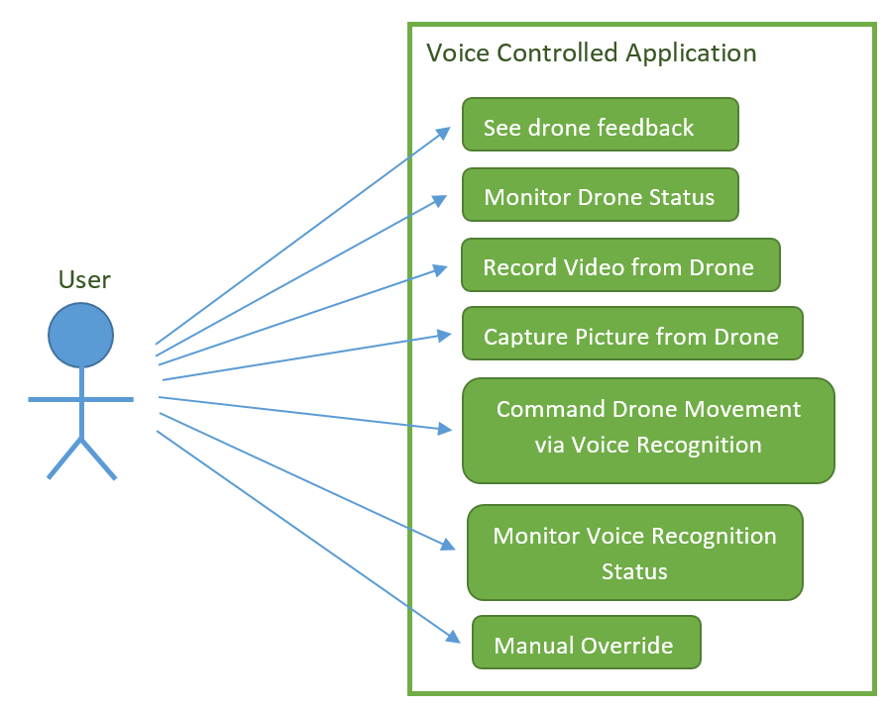

Figure 1. Use Case Diagram

1. **Sequence Diagram**

Sequence diagram below explains how the operation is performed by the application. Here is how the operation works.

Users will sent a data from his/her phone after user give commands using voice to drone via “Voice Controlled Drone” application, the software will translate the user voice into a length of string and sent it to the drone. Then drone will receive the data via Internet and do what the user request. The feedback from drone is request command the drone gets from user to show if the command is successfully executed.

The manually override system is easier to be deployed whereas the user can control the drone via the user phone. There will be buttons-like controller that the user can touch to control the movement such as moving forward, backward, up, down. The user can also do the control off taking off the ground and landing the drone safely. The manually override is used if user want to control manually or the drone voice recognition is not responding as it should be. This is to anticipate unwanted accident.

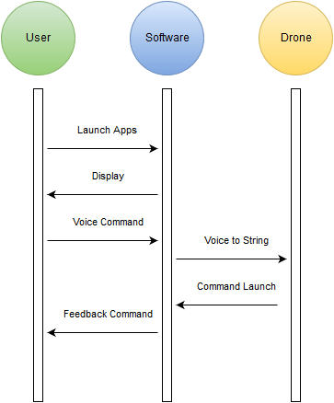

Figure 2. Sequence Diagram

1. **Deployment Diagram**

Deployment diagram illustrates the physical architecture of the system in terms of the hardware deployed on and the communication links between hardware nodes. By connecting via Internet, it is possible to deliver data from phone to drone. The android apps will be installed in an android IP-enabled device whereas the communication between hardware is through a TCP/IP protocol.

C:\Users\HP\AppData\Local\Microsoft\Windows\INetCache\Content.Word\Untitled Diagram(1).png

Figure 3. Deployment Diagram

1. **Activity Diagram**

This diagram describes the flow of activities or tasks. It resembles a flow chart. It has decision points and synchronization bars. The synchronization bars show activities that can happen in either order or even at the same time. “Voice Control Drone” activity diagram below explains the step-by-step activities provide by “Voice Control Drone”. First of all, the software will accept input from the user which is user voice command, and then the system will determine the voice command and translate it to a string. Secondly, the software will sent a data via internet to the drone. If the drone do not give feedback for 5 seconds, the command is consider failed. Otherwise if the command is received by the drone, the drone will sent feedback which is displaying command information that user has given in the beginning. Below is the diagram of Activity Diagram.

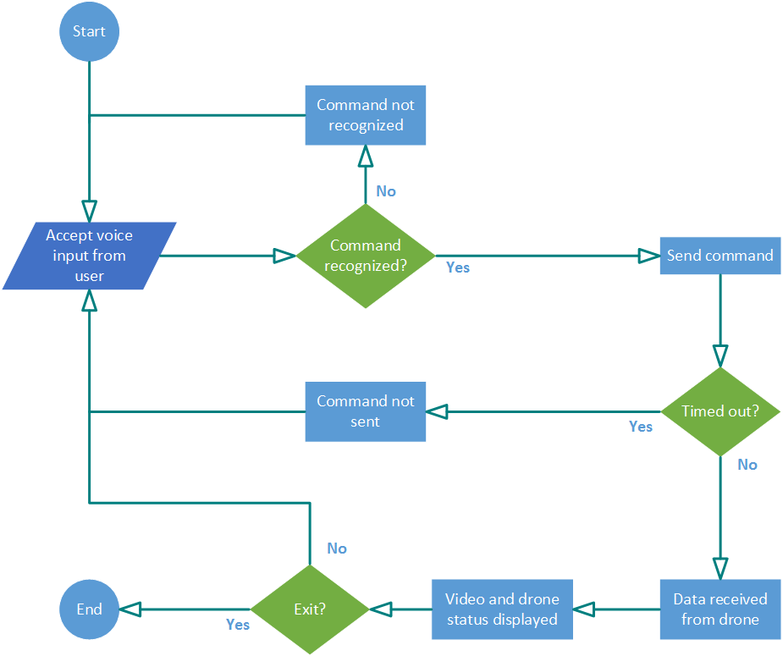

Figure 4. Activity Diagram

1. **Class Diagram**

This diagram explains the class of the program and describes the interconnection between the classes. These class is implemented in the drone. There are two main class in the system between hardware and software. The software classes is provided in display class. In the display the user can see the status of the drone and the command status. There are three main options in the android. There are video class where you can record video and capture picture if you choose this option, using the voice option let the user to edit/add command and sent command using voice, and the about options give you credits and how to use the application. The hardware drone between application communication use the protocol of TCP/IP. This protocol lets you communicate with your phone to control the drone.

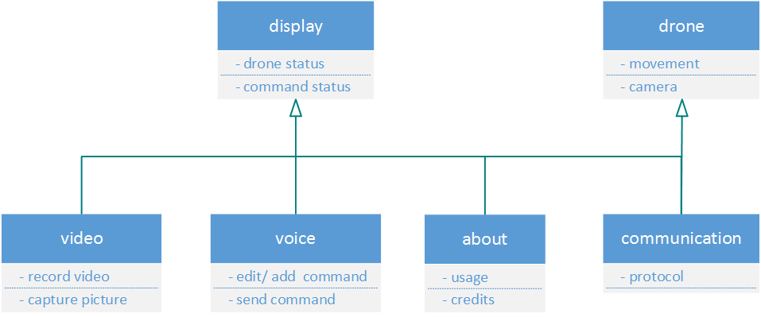

Figure 5. Class Diagram

1. **Communication Diagram**

Communication diagram was called collaboration diagram in UML. It is similar to sequence diagrams but the focus is on messages passed between objects. The same information can be represented using a sequence diagram and different objects. The diagram provided in communication can be explained the same as sequence diagram where you can find the explanation in the sequence diagram.

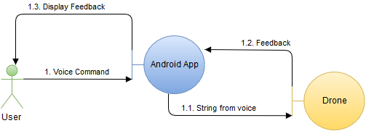

Figure 6. Communication Diagram

1. **Component Diagram**

A component diagram displays the structural relationship of components of a software system. These are mostly used when working with complex systems that has many components. Components communicate with each other using interfaces. The interfaces are linked using connectors. In the diagram provided below show the main android application software system is link to google location API and google speech to text API.

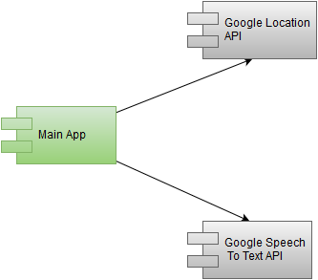

Figure 7. Component Diagram